Step 1. Research the task

The task description and provided dataset archive were first reviewed to understand data structure, annotation formats, and project requirements.
After researching I define that *_simple.json files contain suitable annotations for this task. So next step for me will be extract the right crops from data.

Step 2. Data preparation

The *_simple.json files were selected because they provide simplified, page-aligned bounding box annotations suitable for direct image cropping.
The provided annotated_pdfs_and_data dataset was converted into an image classification dataset compatible with Ultralytics YOLO (ImageFolder format).
For each drawing page, cabinet instances were extracted using bounding boxes from *_simple.json annotations. Each cabinet is saved as a cropped image (optionally padded and clamped to image boundaries) under its corresponding class directory. Only in-scope cabinet categories were included.
Target Classes
- lc:bcabo
- lc:wcabo
- lc:muscabinso
- lc:wcabcub
- lc:bcabocub

Train / Validation / Test Split
To avoid information leakage, the dataset was split at the page level, ensuring that all cabinet instances from the same drawing page appear in only one split.
The dataset was divided into:
- 60% training
- 20% validation
- 20% test
Because cabinet instances are unevenly distributed across pages and some classes are rare, a purely random page split can lead to empty or highly imbalanced splits. To address this, the following steps were applied:
- Initial random page split according to the target ratios.
- Class coverage enforcement: pages were reassigned if a target class was missing or significantly under-represented in validation or test splits.
- Instance-aware page selection: when promoting pages, preference was given to pages whose instance counts best matched the desired split fraction.
- De-overfill pass: pages were moved back to training when frequent classes became over-represented in validation or test, while preserving minimum coverage for rare classes.
This approach preserves page-level isolation, guarantees class presence in all splits when possible, and produces a balanced and stable dataset suitable for evaluation.
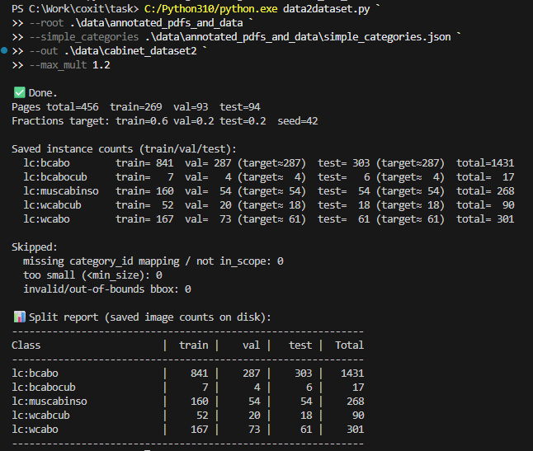
Script in \data2dataset.py file.

Step 3. Balance classes

To mitigate severe class imbalance, I oversampled minority classes in the training set by duplicating samples to achieve a more balanced class distribution, while keeping the validation set untouched to preserve unbiased evaluation.
Oversampling was applied only to the training set to avoid biasing validation and test metrics.
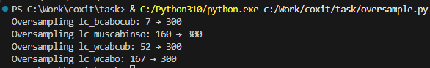
Script in \oversample.py file.

Step 4. Training & Test

YOLOv8 classification was selected due to prior hands-on experience with the framework, which enabled faster iteration and reliable configuration. A pretrained yolov8n-cls model was fine-tuned on the cabinet dataset.
Training parameters:
- epochs = 50: sufficient for convergence on a medium-sized dataset
- imgsz = 224: standard input resolution for image classification
- batch = 32: balanced GPU utilization and training stability
- lr0 = 1e-3: standard learning rate for fine-tuning YOLO classification models
- patience = 10: early stopping to prevent overfitting
- device = 0: training performed on a single GPU
This setup provided stable convergence while minimizing overfitting on smaller classes.

Training results

Training stopped early on 24/50 epoch as no improvement observed in last 10 epochs. Best results observed at epoch 14.
Normalized confusion matrix:
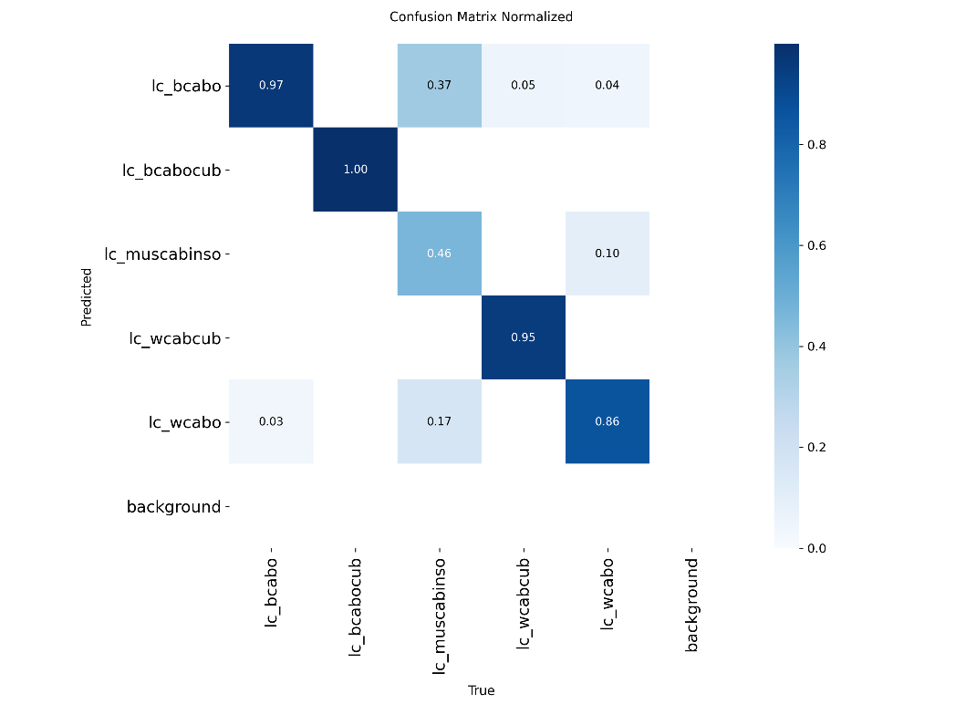
The confusion matrix demonstrates strong discriminative performance for the primary cabinet categories, with high recall for base and wall cabinet classes. Confusions are mainly observed between visually similar categories, particularly miscellaneous cabinet inserts and standard cabinet types, which is consistent with their overlapping structural characteristics. Performance on rare classes should be interpreted cautiously due to limited sample sizes. Overall, the results indicate that the model has learned meaningful visual representations of cabinet types while respecting class boundaries.

Test results

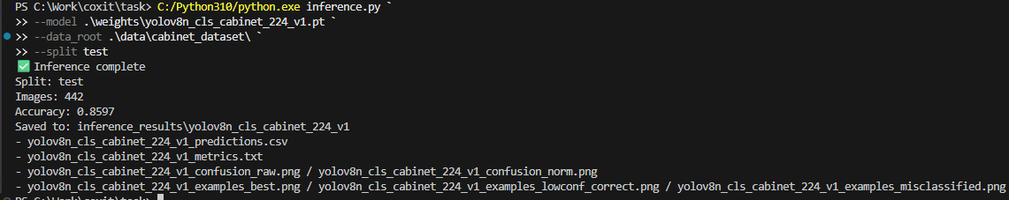
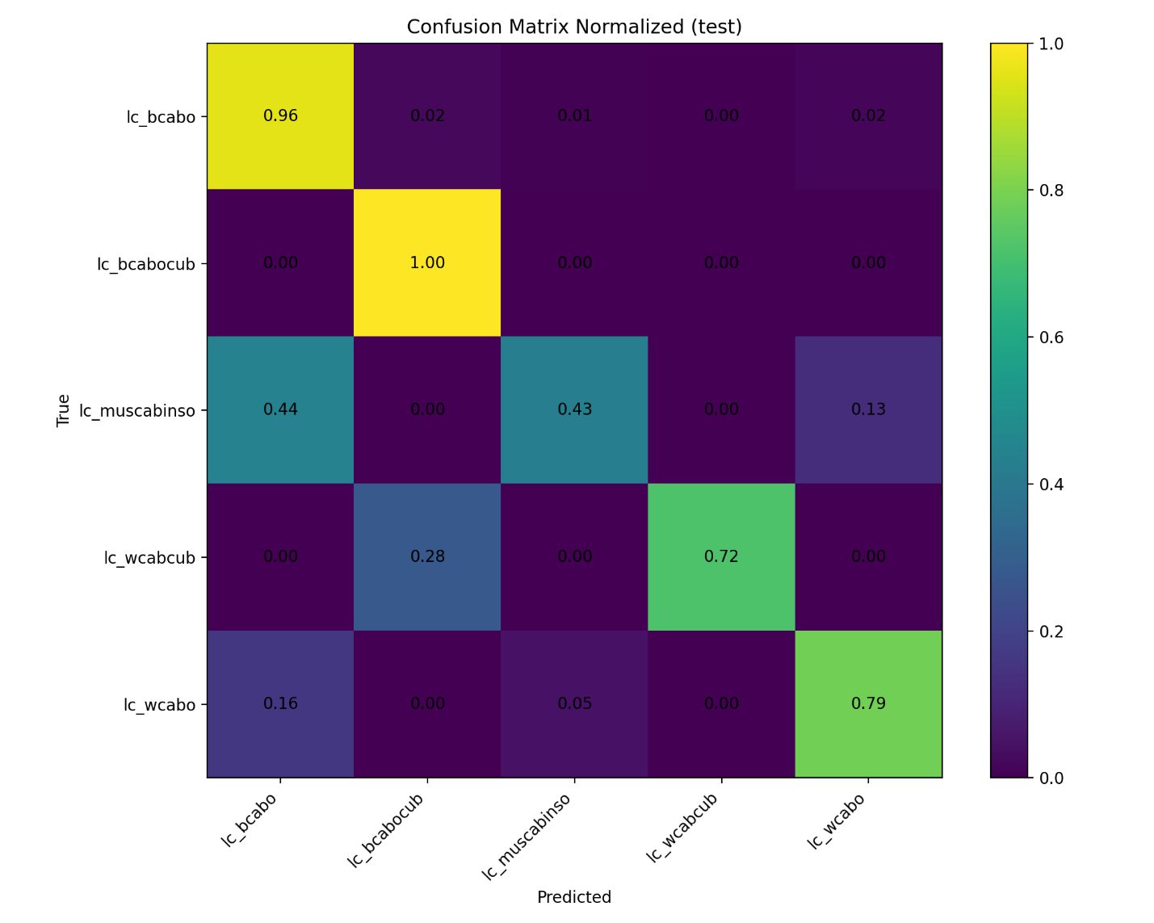

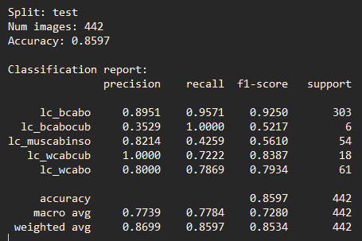
Script in \inference_yolo.py file.
All metrics are reported on the held-out test set to reflect true generalization performance.

Step 5. Model experimentations

YOLO11n-cls

Training parameters:
- epochs = 50
- imgsz = 224
- batch = 32
- lr0 = 1e-3
- patience = 10
- device = 0
- workers = 1: Not enough memory with default value

Training stopped early on 16/50 epoch as no improvement observed in last 10 epochs. Best results observed at epoch 6.

Test results:
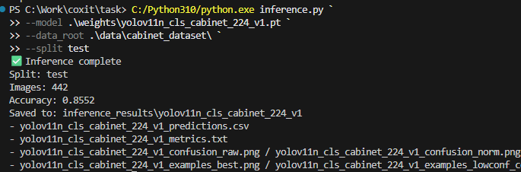
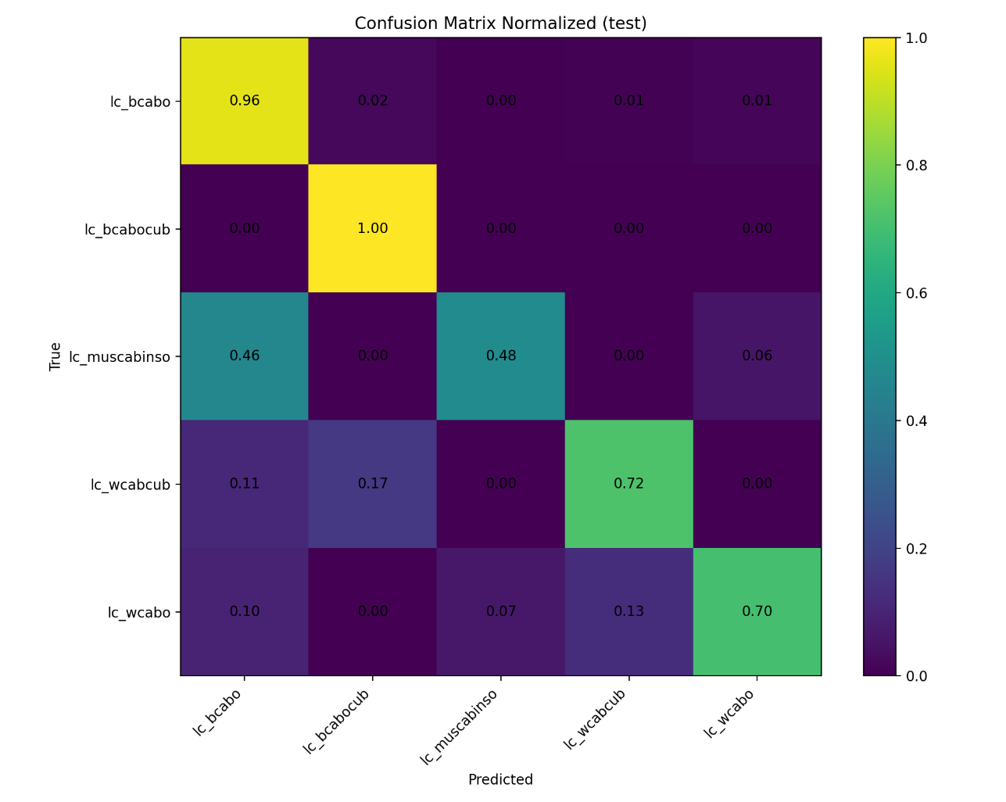
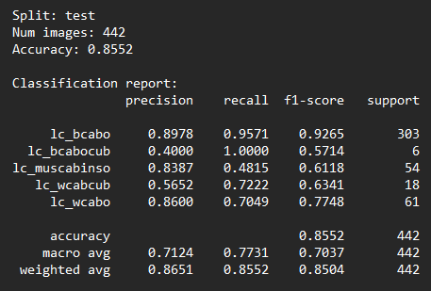
Overall, YOLOv8 provides more stable and consistent class separation, while YOLOv11 shows minor improvements on some underrepresented classes but does not provide a meaningful overall accuracy gain compared to YOLOv8.

YOLOv8m-cls

Training parameters:
- epochs = 50
- imgsz = 224
- batch = 32
- lr0 = 1e-3
- patience = 10
- device = 0
- workers = 1

Training stopped early on 35/50 epoch as no improvement observed in last 10 epochs. Best results observed at epoch 25.

Test results:
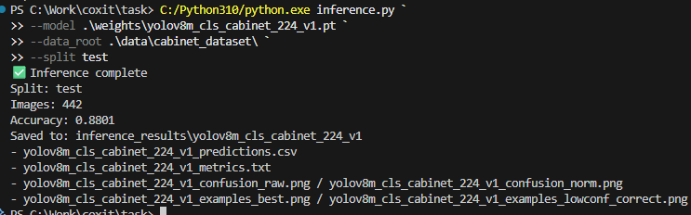
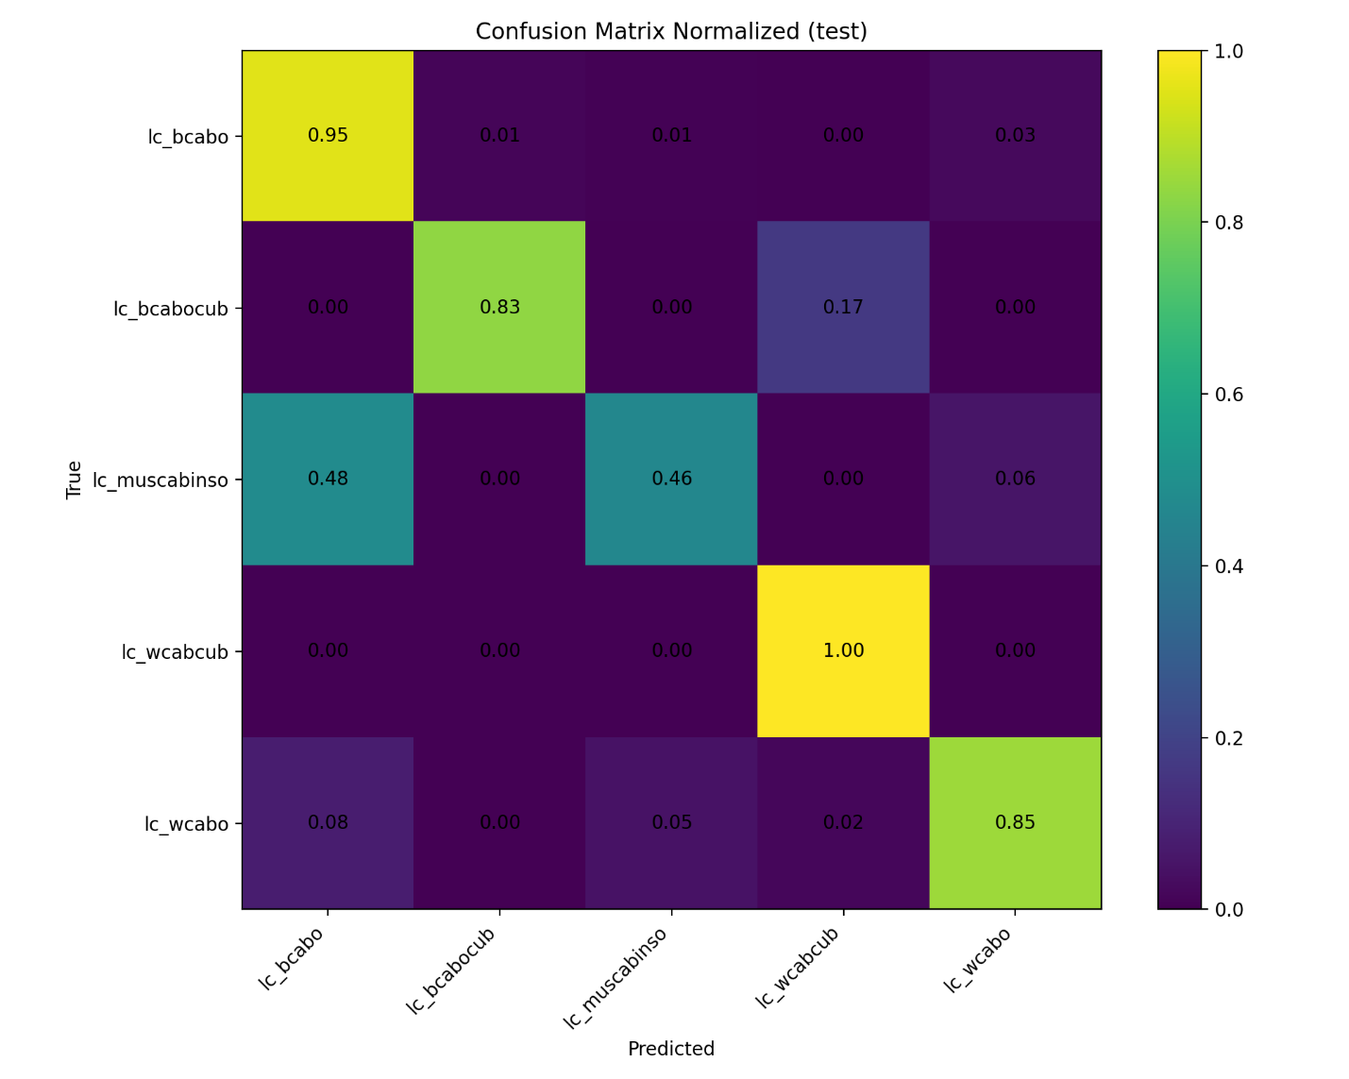
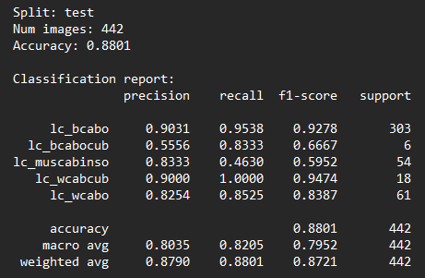

YOLOv8m (test set) shows a clear improvement over smaller models, achieving 88.0% accuracy with higher recall on the main cabinet classes. Performance is especially strong for lc_bcabo, lc_wcabcub, and lc_wcabo, while minority classes (lc_bcabocub, lc_muscabinso) still benefit from the larger capacity but remain limited by data imbalance.

EfficientNetB2

Training parameters:
- epochs = 30
- imgsz = 224
- batch = 24
- lr = 1e-3
- patience = 8
- device = 0
- workers = 4
- model = tf_efficientnet_b2 : new model
- use_weighted_sampler : use WeightedRandomSampler to reduce class imbalance effects.

Training stopped early on 17/30 epoch as no improvement observed in last 8 epochs.

Test results:
Script in \inference_efficientnet.py file.
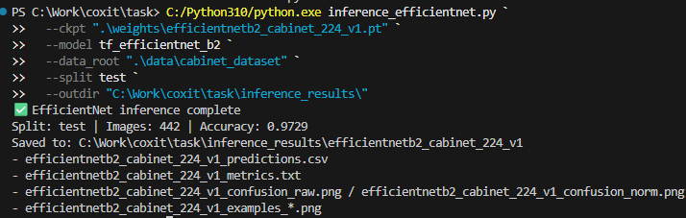
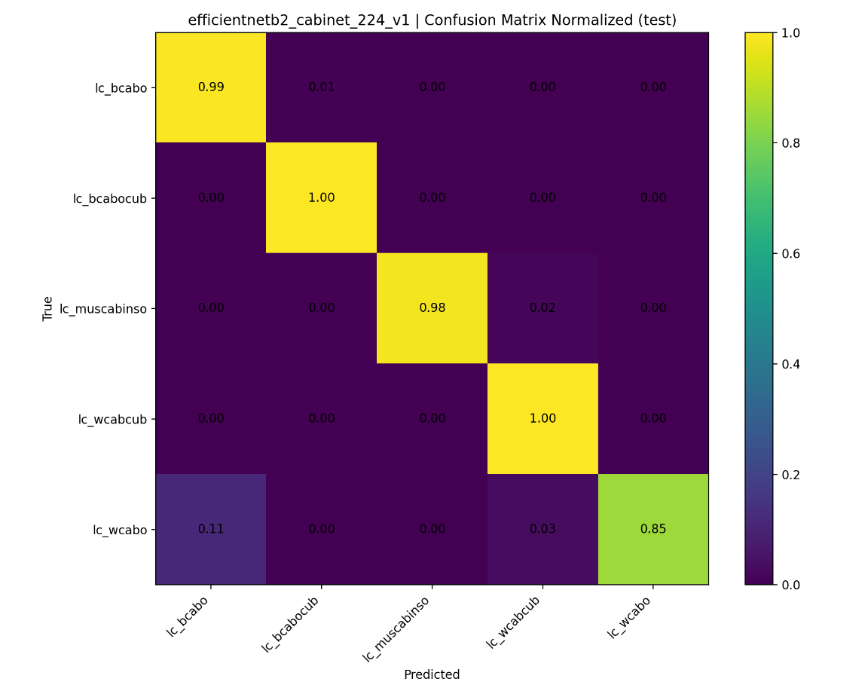
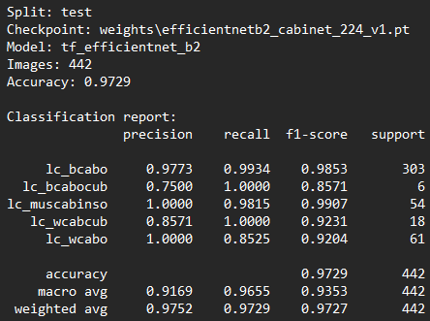

EfficientNet-B2 (test set) achieves 97.3% accuracy, significantly outperforming smaller models. It shows near-perfect recall across all cabinet classes, including minority ones (lc_bcabocub, lc_wcabcub, lc_muscabinso), and strong overall balance (macro F1 = 0.94), indicating effective handling of class imbalance and improved generalization with increased model capacity.
This performance is achieved with weighted sampling during training, which significantly improves minority-class recall.

ConvNeXT Tiny

Training parameters:
- epochs = 30
- imgsz = 224
- batch = 32
- lr = 5e-4: suitable for convnext tiny
- patience = 8
- device = 0
- workers = 4
- model = convnext_tiny : new model
- use_weighted_sampler : use WeightedRandomSampler to reduce class imbalance effects.

Training stopped early on 19/30 epoch as no improvement observed in last 8 epochs.

Test results:
Script in \inference_convnext.py file.
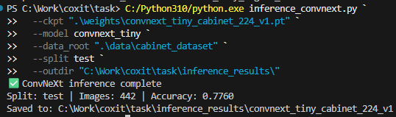
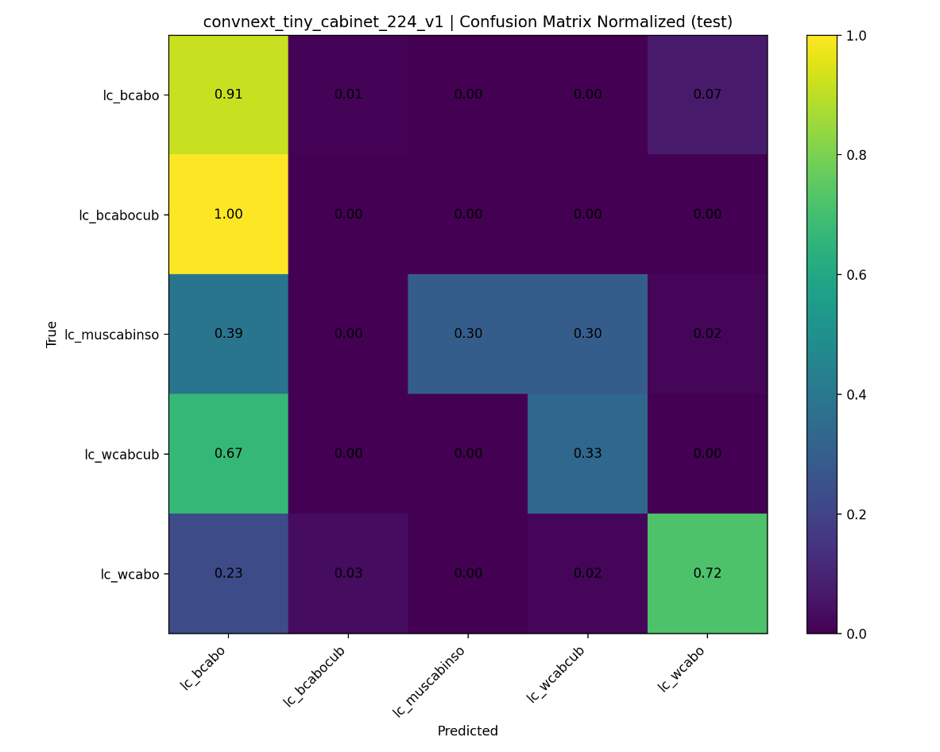
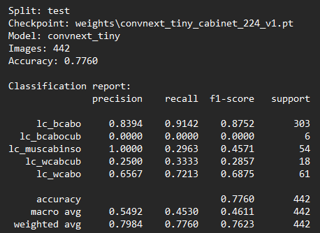

ConvNeXt-Tiny (test set) achieves 77.6% accuracy, performing well on the dominant class (lc_bcabo) and reasonably on lc_wcabo. However, minority classes—especially lc_muscabinso and lc_bcabocub—are often confused, showing sensitivity to class imbalance.

Summary

We evaluated multiple classification architectures on the same cabinet dataset using a fixed 60/20/20 (train/val/test) split and identical preprocessing.
Models tested:
- YOLOv8n-cls / YOLOv8m-cls – fast CNN-based classifiers
- YOLOv11n-cls – newer YOLO classifier with improved accuracy–speed tradeoff
- EfficientNet-B2 – strong CNN baseline optimized for accuracy
- ConvNeXt-Tiny – modern transformer-style CNN
Key findings:
- EfficientNet-B2 achieved the best overall accuracy (≈97.3%), with strong performance across all classes, including minority ones.
- YOLOv11n-cls slightly outperformed YOLOv8n-cls in accuracy, with similar latency.
- YOLOv8m-cls improved accuracy over YOLOv8n-cls at the cost of higher latency.
- ConvNeXt-Tiny underperformed on minority classes and showed the weakest overall results.
- Accuracy–latency tradeoff clearly favors EfficientNet-B2 for quality and YOLOv11n-cls for speed.
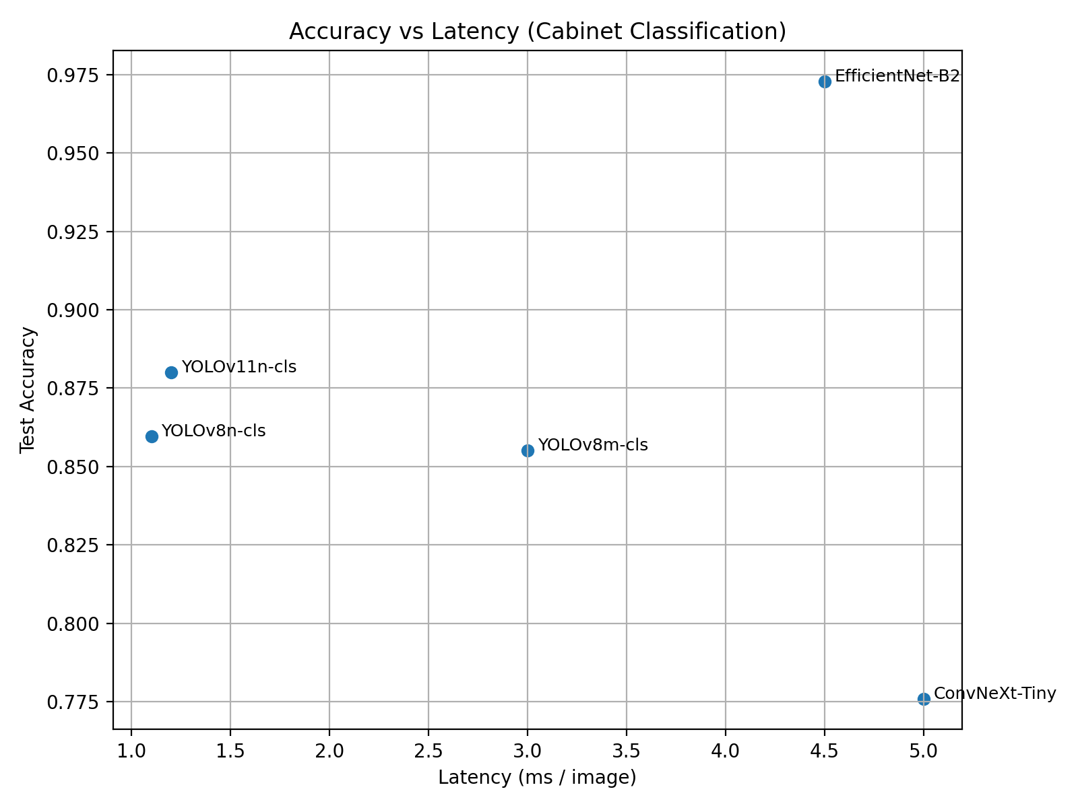

Possible Improvements

Several directions could further improve performance and robustness of the cabinet classification system:
- Data augmentation: introduce stronger geometric (rotation, perspective) and photometric (contrast, noise) augmentations, especially to improve generalization for rare classes.
- Crop strategy: experiment with different padding ratios around bounding boxes and context-aware crops to preserve surrounding visual cues.
- Input resolution: evaluate higher image sizes (e.g. 256 or 320) for models sensitive to fine details.
- Class imbalance handling: combine weighted sampling with class-weighted or focal loss to further stabilize learning on minority classes.
- Model exploration: test larger variants (EfficientNet-B3/B4, ConvNeXt-Small) and transformer-based classifiers (ViT, Swin) to assess scalability.
- Ensembling: combine predictions from multiple models (e.g. EfficientNet + YOLO) for improved accuracy.
- Hard example mining: focus training on consistently misclassified samples to reduce confusion between visually similar cabinet types.
- Repository structure improvement: The repository can be further improved by grouping training, inference, and utility scripts into dedicated submodules (e.g., train/, inference/, utils/) and introducing a unified configuration system to simplify experiment management and reproducibility.
These extensions would help better understand model limits and potentially improve both accuracy and reliability in real-world deployment.

